DIGITAL WALLET
@CREATIVITY THINK (9483175986/7019689991)

ABSTRACT:
Digital Wallet is a web application designed to provide users with secure and convenient digital payment services. Users can add funds, transfer money to other users, and view transaction history with analytics dashboards for tracking financial activities. Administrators can manage users, wallets, and limits while accessing detailed analytical dashboards to monitor usage. The backend is built using Django and Django Rest Framework to ensure secure data management, authentication, and business logic, while the frontend uses React, Axios, and Recharts to provide interactive dashboards and real-time transaction insights..

INTRODUCTION OF THE PROJECT:
The increasing need for cashless transactions and seamless digital payments has prompted the development of Digital Wallet. This platform allows individuals and organizations to manage funds, transfer money, and monitor financial activities conveniently. Administrators can oversee user wallets, enforce limits, and track analytics to ensure security and transparency. Using Django and Django Rest Framework for the backend and React, Axios, and Recharts for the frontend, the system delivers secure, real-time transaction management with user-friendly dashboards for both users and administrators..

PROJECT OBJECTIVES:

• Enable users to register and manage digital wallets
• Facilitate secure fund addition and money transfers
• Maintain comprehensive transaction history and analytics
• Allow administrators to manage users and wallets efficiently
• Set transaction limits and monitor user activity
• Provide dashboards for real-time insights and reports
• Ensure secure, reliable, and transparent digital financial transactions

PROBLEM OF THE STATEMENT:
With the rise of digital payments, users require a secure, centralized platform to manage funds, transfer money, and track transaction history. Traditional banking systems may be slow and less flexible for small transactions. Administrators also need an efficient way to manage users, enforce limits, and analyze usage patterns. The Digital Wallet application addresses these challenges by offering secure wallet management, real-time transaction monitoring, and detailed analytical dashboards, ensuring user convenience and administrative oversight..

MOTIVATION OF THE PROJECT:
• Facilitate cashless and seamless financial transactions
• Provide secure and reliable digital wallet services
• Enable users to track transaction history and financial activity
• Allow administrators to monitor wallets and enforce limits
• Support data-driven financial insights through dashboards

BLOCK DAIGRAM OF PROJECT:

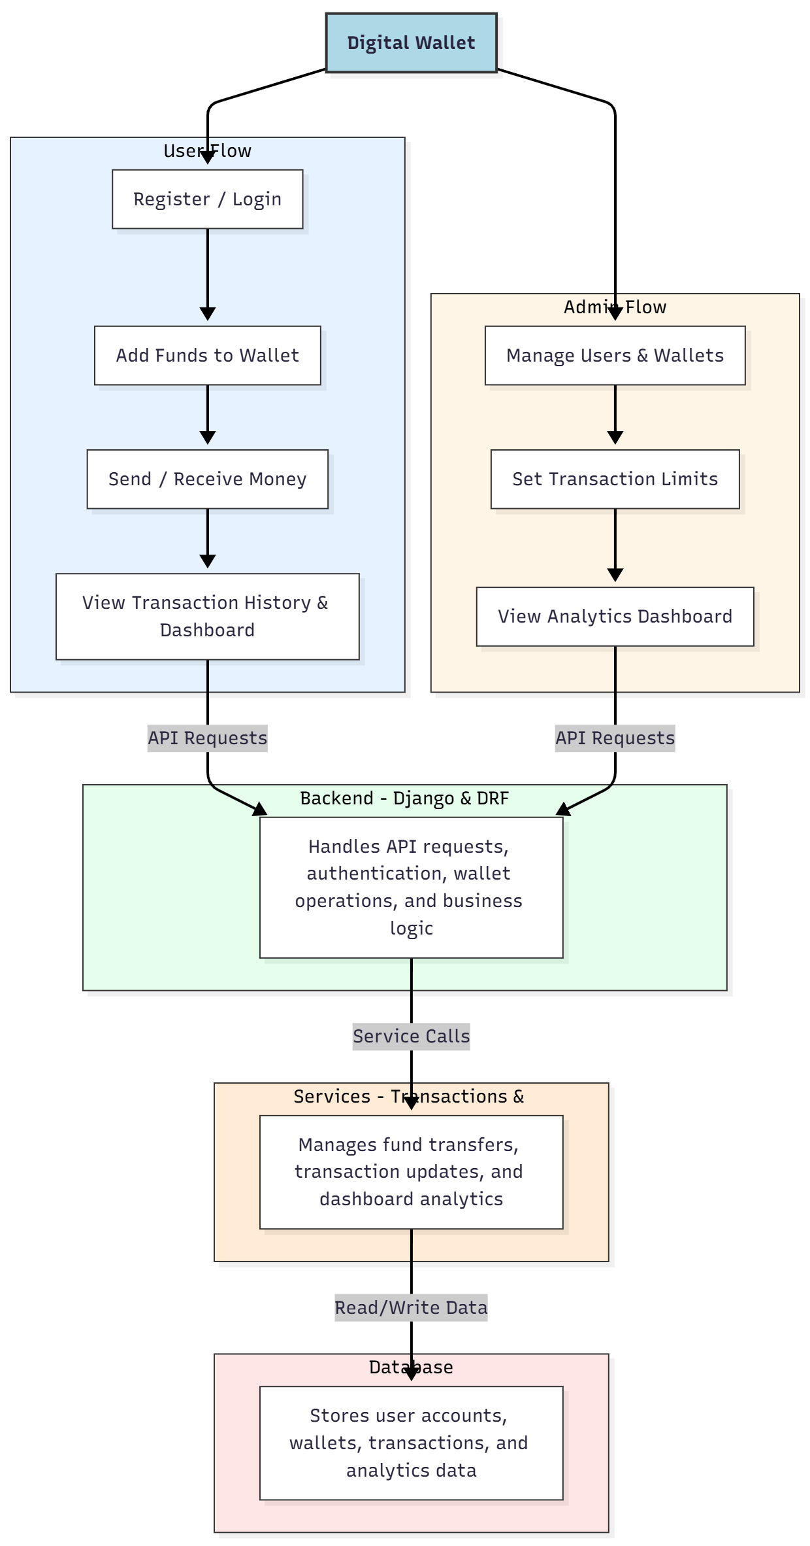

WORKING OF THE PROJECT:
Users register or log in, add funds to their wallet, send or receive money, and view a complete transaction history through interactive dashboards. The backend processes API requests, manages wallet operations, and ensures secure authentication. Services handle real-time transactions and update analytical dashboards. Administrators can manage user wallets, set transaction limits, and monitor overall activity through analytics dashboards. This system ensures secure, fast, and transparent digital financial transactions for both users and administrators..

SOFTWARE REQUIREMENT:
- Backend:
  - Python 3.x
  - Django
  - Django REST Framework
  - SQLite/PostgreSQL
- Frontend:
  - Node.js and npm
  - React.js
  - Axios
- Development Tools:
  - Visual Studio Code
  - Postman (for testing APIs)
  - Git/GitHub (for version control)
- Server/Deployment (Optional):
  - Gunicorn, Nginx, or Heroku/AWS for hosting

ADVANTAGES OF THE PROJECT:

• Secure digital wallet services for individuals and organizations
• Real-time fund addition and money transfers
• Comprehensive transaction history and reporting
• Administrative control over users and wallets
• Transaction limit enforcement
• Interactive dashboards for analytics
• Multi-device web accessibility
• Transparent and reliable financial operations

APPLICATIONS OF THE PROJECT:
• Individual digital payments and personal finance management
• Organizational fund management
• Peer-to-peer money transfers
• Financial transaction tracking for small businesses
• Administrative wallet oversight
• Data-driven analytics for financial monitoring
• Digital payment integration for e-commerce platforms
• Cashless transaction ecosystems

REFERENCES:

- Django REST Framework Documentation — Django Software Foundation. Django Documentation. Available: https://docs.djangoproject.com/
- Django REST Framework. DRF Documentation. Available: https://www.django-rest-framework.org/
- React. React Official Documentation. Available: https://reactjs.org/docs/getting-started.html
- Redux. Redux Documentation. Available: https://redux.js.org/introduction/getting-started
- PostgreSQL Global Development Group. PostgreSQL Documentation. Available: https://www.postgresql.org/docs/
- MySQL. MySQL Reference Manual. Available: https://dev.mysql.com/doc/
- Git. Git Documentation. Available: https://git-scm.com/doc
- Node.js. Node.js Documentation. Available: https://nodejs.org/en/docs/
- Axios. Axios Documentation. Available: https://axios-http.com/docs/intro
- Socket.io Documentation – https://socket.io/docs/

